ARCHITECTURAL AND ENGINEERING DESIGN SERVICES
REQUEST FOR PROPOSAL (RFP)

REQUEST FOR PROPOSALS
February 27, 2024

SUBMITTALS DUE BY 6 pm local time, April 5, 2024

RFP submitted by: Meg Wempe, Director, Upper San Juan Library District
NOTICE TO RESPONDENTS
(A respondent is defined as a company or individual that responds to this RFP.)
NOTICE IS HEREBY GIVEN that proposals and qualifications are being solicited by the Upper San Juan Library District (USJLD) to obtain complete and final architectural design services as described herein for the Ruby M. Sisson Memorial Library. Individuals or firms responding to this Request for Proposal should have extensive experience, a knowledgeable background and qualifications in the provision of the services described herein.

- GENERAL OVERVIEW

- OVERVIEW: The Upper San Juan Library District (USJLD) has determined the need to expand the Ruby M. Sisson Memorial Library, located in Pagosa Springs, Colorado, to create more space for programming and services. The Library’s 7300sq. ft. facility was originally constructed in 1989 and underwent an expansion in 2005. It is the USJLD’s desire to expand and renovate the facility to align with our mission and vision of a 21st century library. The USJLD also envisions an upgraded and expanded library that offers a warm, welcoming atmosphere, quiet reading spaces and public meeting places, bright and cheery youth areas, and the latest resources and technology for everyone. A conceptual plan was designed by RATIO Architects out of Denver, Colorado, through a design feasibility study completed in 2020. We plan to add a renovated and expanded building size of approximately 11,300 square feet to include:
- 150-seat Library Community Room designed to fit a variety of uses;
- Dedicated Children’s Discovery Room for early literacy programming, connected to the Charity Jane Children’s Garden;
- Dedicated Teen/Tween Hub for education, entertainment, and enjoyment;
- Private study rooms;
- Collaborative makerspace for intergenerational, hands-on learning;
- Easy access to self-checkout and item drop off;
- Outdoor reading garden that is easily accessible from the Library and from outside.

The USJLD intends to solicit proposals from qualified firms, evaluate the results, interview and select a firm to perform architectural and engineering design work related to the renovation and expansion of the Library. The USJLD anticipates the selected architectural firm will oversee the review and updating of the existing preliminary design concepts to include complete schematic design, design development and production of construction documents.

Additional details regarding the scope of the current project are included below in section 6. Scope of Work.

- SCHEDULE: Current milestones for the architectural and design services are:
      - Proposals requested Tuesday, February 27, 2024
      - Optional site walk Thursday, March 21, 2024, 8:30 am local time
      - Question period ends Friday, March 29, 2024, 6 pm local time
      - Proposal submissions due Friday, April 5, 2024, 6 pm local time
      - Evaluation period Monday, April 8, 2024 – Friday, April 19, 2024
      - Selection announcement Friday, April 26, 2024

- RFP SUBMITTAL: Proposals, and all attachments, shall be received by Friday, April 5, 2024, 6 pm local time at the Ruby M. Sisson Memorial Library located at 811 San Juan Street. Proposals may be mailed to PO Box 849, Pagosa Springs, CO 81147 or hand delivered during regular business hours (9:00 am to 6:00 pm Monday, Wednesday, Friday; 9:00 am to 8:00 pm Tuesday and Thursday; 9:00 am to 3:00 pm Saturday). Submittals may be delivered via email, clearly identified in the subject line with “RFP for architectural and engineering design services” to director@pagosalibrary.org. All proposals will be reviewed by a committee which consists of members selected by the Upper San Juan Library District Board of Trustees and the Ruby M. Sisson Memorial Library Foundation Board of Directors. Selection will be based on 1) knowledge and experience of the firm doing the work; 2) satisfactory recommendations from past clients; 3) cost; 4) detail and understanding of the scope of work as demonstrated in the proposal.

- GENERAL TERMS & CONDITIONS
- Interested Parties: All interested parties are invited to submit proposals in accordance with the terms, conditions, and specifications contained herein.

- Tax Exemption: The USJLD, as a Colorado local governmental special district, is exempt from sales and use taxes. Firms shall inform all prospective subcontractors and suppliers from whom they expect to obtain services or supplies of the tax-exempt status of the USJLD. An exemption certificate can be furnished by the USJLD upon request.

- Expenses: The USJLD assumes no liability for payment of expenses incurred by firms in the preparation and submission of information in response to this invitation.

- Non-Discrimination: The firm agrees not to refuse to hire, discharge, promote or demote, or to discriminate in matters of compensation against any person otherwise qualified, solely because of race, color, religion, national origin, gender, age, military status, sexual orientation, marital status, or physical or mental disability.

- Governing Law: The laws of the State of Colorado shall govern any agreement executed between the successful firm and the USJLD. Furthermore, the place of performance and transaction of business shall be deemed to be in the County of Archuleta, State of Colorado, and in the event of litigation, the exclusive venue and place of jurisdiction shall be Archuleta County in the State of Colorado.

- Confidentiality: Submittals to the USJLD for consideration shall be considered the property of the USJLD and subject to Colorado Open Record Law, Section 24-72-201, et seq., C.R.S.

- Confidentiality of Information: The submitting firm acknowledges that the firm will, or may, be making use of, acquiring, or adding to information about certain matters and things that are confidential to the USJLD, and is the exclusive property of the USJLD, including, but not limited to, legal documents and contracts, personnel and financial information, purchasing and internal cost information, operational manuals, IT schema and passwords, and other proprietary manners and methods of the USJLD’s business and operations. The firm affirms to respect these confidential matters and only divulge these to others with the express written permission of authorized representatives of the USJLD.

- SUBMITTAL PREPARATION
- EXCEPTIONS AND DEVIATIONS: Any exceptions to or deviations from these terms and conditions must be identified, in writing, on an attachment to the submittal. The USJLD reserves the right to accept or reject, at its sole discretion, any exceptions or deviations by the firm.

- SUBSTANTIVE SUBMITTALS: By submitting information in response to this RFP, the firm guarantees that (1) its submittal is genuine and is not made in the interest of, or on behalf of, any undisclosed person, firm, or corporation; (2) it has not directly or indirectly induced or solicited any other respondent to put in a false or sham bid; (3) it has not solicited or induced any other person, firm, or corporation from proposing; and (4) it has not sought by collusion to obtain for itself any advantage over any other firm or over the USJLD.

- MINIMUM QUALIFICATIONS: To be considered for selection, firms must meet at least the following minimum qualifications:

      - Established business. Firms must assign qualified architect(s) to this project who are licensed to practice in Colorado. The firm must have provided architectural and design services for a minimum of five years prior to the release date of this RFP.

      - Customer Satisfaction, Financial Resources and Ability to Perform. The firm must be able to show proof that they have an established satisfactory record and have sufficient financial support, equipment, and organization to ensure that they can satisfactorily execute the services to be performed per this RFP.

      - Legal compliance. The firm must be in compliance with all applicable laws, rules, regulations, and ordinances of the Town of Pagosa Springs, County of Archuleta, the State of Colorado, and the United States.

      - Insurance. The firm shall not commence work until it has procured, maintains, and provides proof of the policies of insurance and liabilities listed below. The firm will not be relieved of any liability, claims, or other obligations in conjunction with the signed agreement with the USJLD by reason of its failure to procure or maintain the necessary insurance and liabilities. Failure on the part of the firm to obtain such insurance and liabilities prior to, and during the term of the contract, will constitute a breach in which the USJLD has the right and may immediately terminate the engagement. The USJLD reserves the right to request and receive a copy of any policy related to the services provided to the USJLD.

- Commercial General Liability: The firm shall secure and maintain, during the term of agreed contract and for such additional time for service being performed, Commercial General Liability Insurance issued to and covering the liability of the firm with respect to all work performed by the firm and its third party firms under the contact, to be written on a comprehensive policy form. This insurance shall be written in amounts not less than $1 million for each occurrence and aggregate for personal injury including death and bodily injury and $1 million for each occurrence and aggregate for property damage. This policy of insurance shall name the Upper San Juan Library District, its agents, officers, and employees as additional insured. This policy shall have all necessary endorsements to provide coverage without exclusion for explosion and collapse hazards, underground property damage hazard, blanket contractual coverage’s, as well as owners’ and firms’ Protective Liability (OCP) coverage. The policy shall also provide coverage for contractual liability assumed by the firm under the provisions of the contract and “Completed Operations and Projects Liability” coverage.

- Worker’s Compensation Insurance: The firm shall procure and maintain Worker’s Compensation Insurance, fully complying with the provisions of the Worker’s Compensation Act of the State of Colorado, during the period of this contract and for such additional time as work on this project is being performed.

- SUBMISSION INFORMATION AND DOCUMENTS: The following information and documents shall be included in the submission: Name of firm, address, telephone number, email address, website URL, and contact person’s name.

- IRS FORM W-9: Firm awarded the contract must submit a completed and signed IRS Form W-9 to the USJLD before contract begins.

- SIGNATURES: The submittal must be in ink and signed by a person qualified to bind the firm.

- WITHDRAWAL OF SUBMITTALS: A firm may withdraw its submittal at any time prior to the due date and time as identified herein. After that date and time, no firm may withdraw its submittal for any reason. All submittals shall be valid for a period not less than 90 calendar days after the RFP due date.

- SELECTION

No submittal will be considered unless it is complete. All submittals will be first screened to determine minimum qualifications as outlined in this RFP. Submittals that do not meet these minimum requirements will automatically be rejected and shall not undergo further evaluation. The submittals will be ranked based on the ability of each submitting firm to provide the best combination of quality and value to the USJLD. It is anticipated that the firms with the highest-ranking submittals will be invited for interview and subsequently, the firm considered to offer the best combination of quality and value will be selected for the project.

- NEGOTIATION

Subsequent to the RFP due date, the USJLD reserves the right to negotiate terms and conditions with firms. The USJLD reserves the right to negotiate modifications to a submittal with a single firm without obligation to negotiate similar modifications with other firms.

- SCOPE OF WORK

The USJLD is seeking proposals from qualified firms for architectural design and related services for the expansion and renovation of the Ruby M. Sisson Memorial Library, 811 San Juan Street, Pagosa Springs, Colorado.

By way of background, the USJLD completed a design study in 2020 under the direction of RATIO Architects. Proposers may learn more about the master plan and the building campaign at Our Building Campaign - Upper San Juan Library District (Ruby M. Sisson Memorial Library) (pagosalibrary.org)

The design recommendations described in the plan cited above are to be reviewed and updated as part of the scope of the current project. This review is to be conducted in consultation with the USJLD and will be followed by schematic design and design development in 2024 with all construction documents included.

The full timeline for completing the design and construction is 2024-2026 and the current total budget is $4 million inclusive of design, construction, furnishings, fixtures, and equipment. A final timeline for completion will be determined by the USJLD in consultation with the design team, construction manager, and others. The USJLD anticipates library operations will continue to function during final project design and will close as little as possible during construction.

The firm shall provide the following disciplines (at a minimum) either with in-house professionals or sub-consultants if applicable.
- Civil Engineering
- Structural Engineering
- MEP Engineering
- Landscape Architecture
- Interior Design, including FF&E
- Lighting Design
- Acoustical Design
- Fire Protection Design
- IT and low-voltage infrastructure design

- SUBMITTAL REQUIREMENTS

List the information requested below in the same order as presented.

Item 1: General Introduction
Provide a simple, concise description of your firm and its history, not to exceed two pages. Additional information or brochures can be included under separate cover. Include in this section:
- Contact person for this selection process
- Location of the nearest office
- Number of years doing business under current name
- Size of firm

Item 2: Experience
Provide a brief description of no more than three projects of a similar size, scope, and use completed within the last five years. Project descriptions should include:
- Building type
- Gross square footage
- Owner reference information
- Contractor
- Type of bid, bid amount, and final cost for the project
- Change order amount
- Design architect
- Project architect
- Lead interior designer
- Include resumes, certifications, education, experience, and qualifications of the above key personnel.

Item 3: Qualifications
Describe your firm’s approach for completing the USJLD’s project, including services provided for the design and construction phases of the work. Address your control capabilities of cost estimating, scheduling, quality control, change order management, and project closeout. What is your preferred method of dealing with the owner during the design phase and how do you address owner concerns/comments?

Provide a contemplated timeline and project schedule with key milestones.

What are the steps in the design process and how do you propose to organize the process?

This project will use a budget to control the project and one that cannot be exceeded. Describe your experience in controlling “design creep”, controlling costs and meeting budget and time constraints. In short, how do you propose to furnish a design that the owner can afford?

Describe professional services performed by your staff and any professional services that you would assign to others, such as civil engineering, structural engineering, mechanical engineering, acoustical engineering, electrical engineering, plumbing engineering, landscape architecture, etc. If you engage specialty consultants, how do you control the quality and timeliness of their work product? Do you accept final responsibility of services performed by others? Describe the interface, if any, of owner representative and any consultants that you may engage for required services. Provide an approximate percentage of outside professional services that you would anticipate using in this project.

Describe how you will communicate progress in the design of this project. Will models, drawings or computer animations be furnished, and if so, at what stages? Will renderings be available for presentation in our fundraising process along with presentation assistance? What role do you expect to play in construction administration during the construction phase of the project? Will you attend regular update meetings during construction and review contractor pay applications? Will you provide construction observation site visits on a regular basis and report to the USJLD any deviations from the design documents and work with USJLD and the contractor in required corrections to work? Will you review project closeout documentation submitted by the contractor? Will you conduct site inspection at the end of the project and create punch list items and issue a certificate of substantial completion?

Describe the technology focus of your firm. The USJLD expects the design and construction team to use an electronic, web-based project management system from design through the construction and close-out phases of the project. The USJLD expects contract documents to be furnished in electronic format that we can review. The USJLD also expects to receive record drawings at the completion of the project to be furnished in electronic format.

Describe your experience in providing professional services when a Contract Manager/General Contractor approach is used.

List the Design Architect, Project Architect, and Lead Interior Designer assigned to this project, and describe each of their respective experience in projects of similar size, type, and systems. List any other projects for which the Design Architect, Project Architect, and Interior Designer would have concurrent responsibility, assuming work starts in 2025.

Item 4: Project Completion
For all projects completed within the last five years, identify separately:
- Has your firm ever filed for bankruptcy?
- Has your firm ever failed to complete a project or been terminated from a project before its completion?

Describe what differentiates the firm’s service from that of other competitors and makes your firm the best choice for this project.

It is expected that the firm selected will approach the project in the most efficient manner possible. A written report must detail cost estimates by component, estimated renovation and construction time frame and potential problems that might be encountered in the renovation and construction process.

Item 6: Compensation
Describe in detail how you are compensated for professional services and how you would expect to be compensated for services rendered to the USJLD for this project and what services are included. Include a description of what party bears the cost of any redesign work required that is caused by (1) owner changes; (2) architect oversight/omission; or (3) redesign required to meet budgetary constraints.

Provide a sample contract form that you would expect to use for this engagement.

- EVALUATION AND SELECTION

The USJLD will review submittals submitted by the RFP deadline and select a short list of qualified firms for interview and final selection. The USJLD will negotiate a contract with the selected firm. The USJLD will select the services and terms that are most advantageous to it.

- RIGHT OF ACCEPTANCE AND REJECTION

The USJLD reserves the right to accept or reject any or all submittals and to waive any formalities, informalities, and deviations, which, in its opinion, best serve the interests of the USJLD. The USJLD will select the submittal that represents the best service for the USJLD.

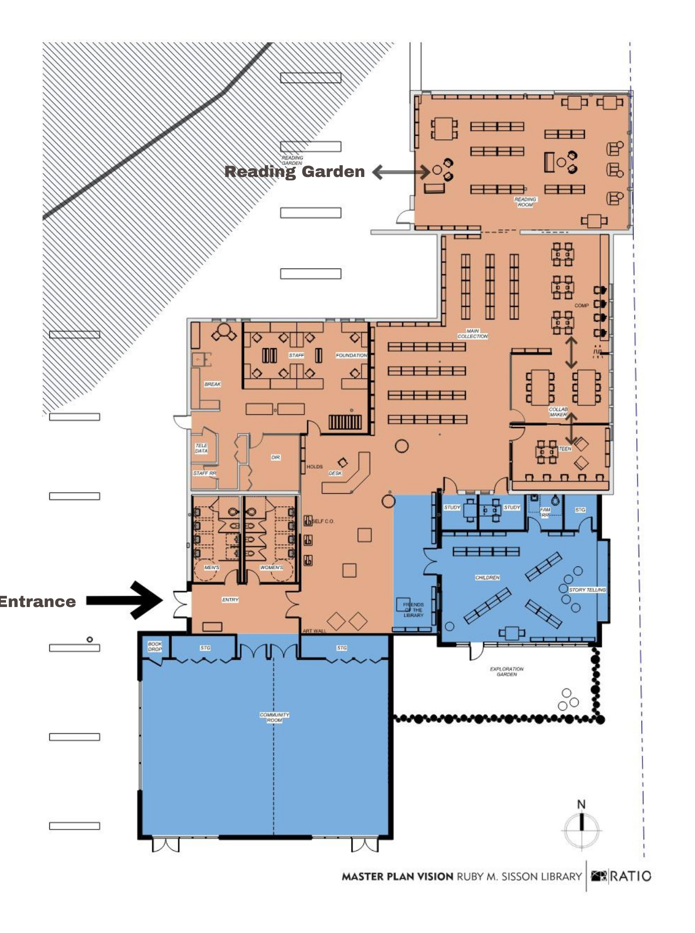Conceptual design from December 2020

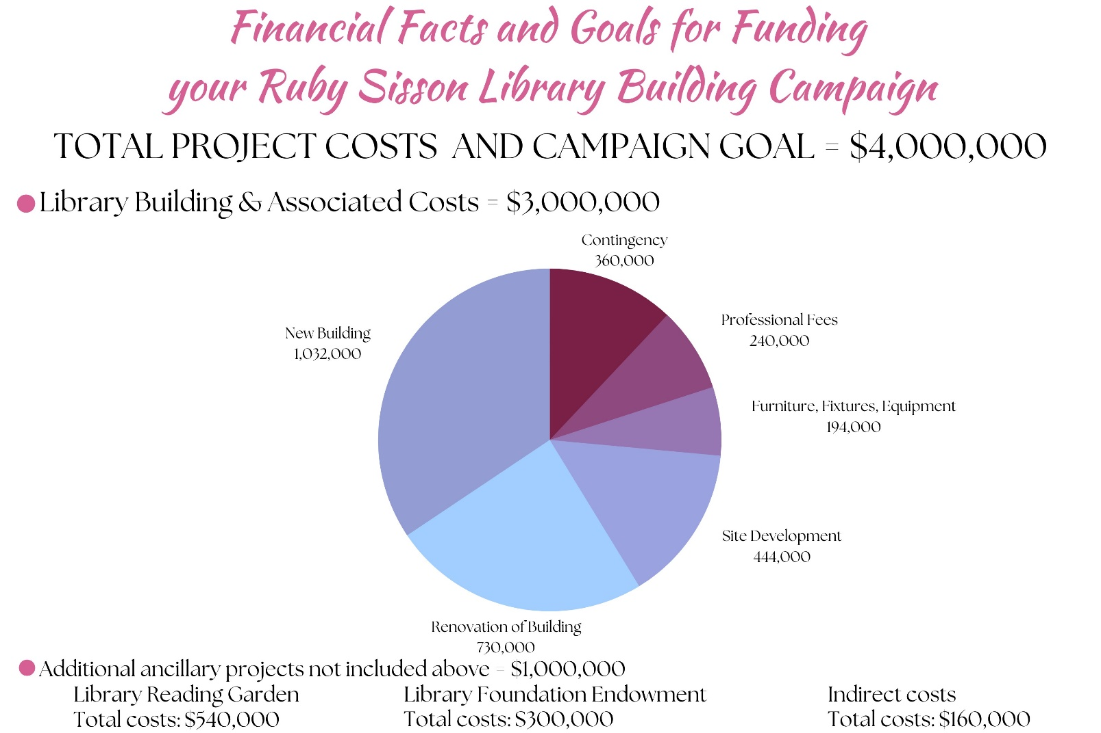
Conceptual costs from December 2020

